SE18

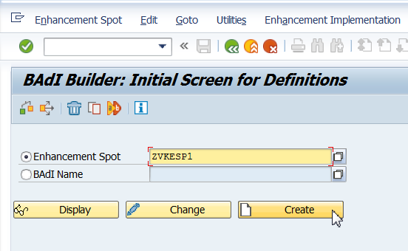

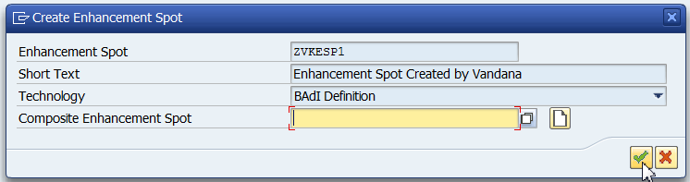Save in package.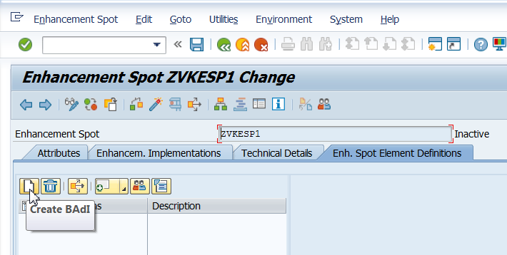

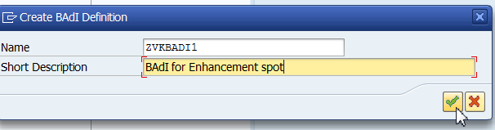

Give the Interface name and create the Interface

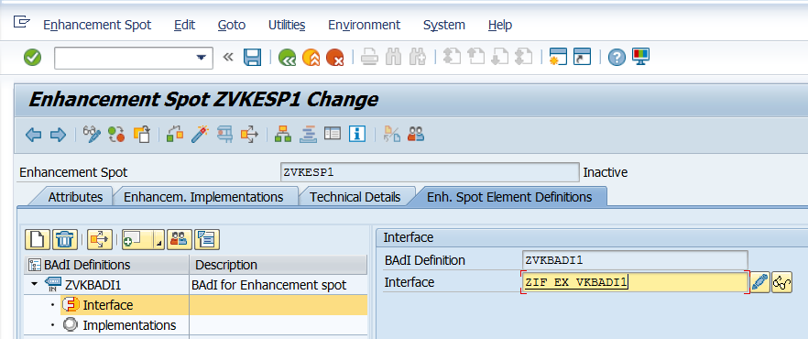Define the methods in the interface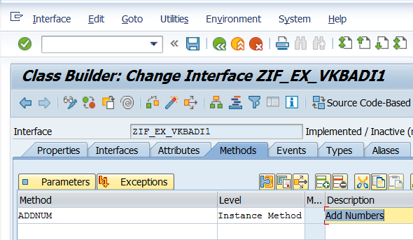

Define Parameters for your method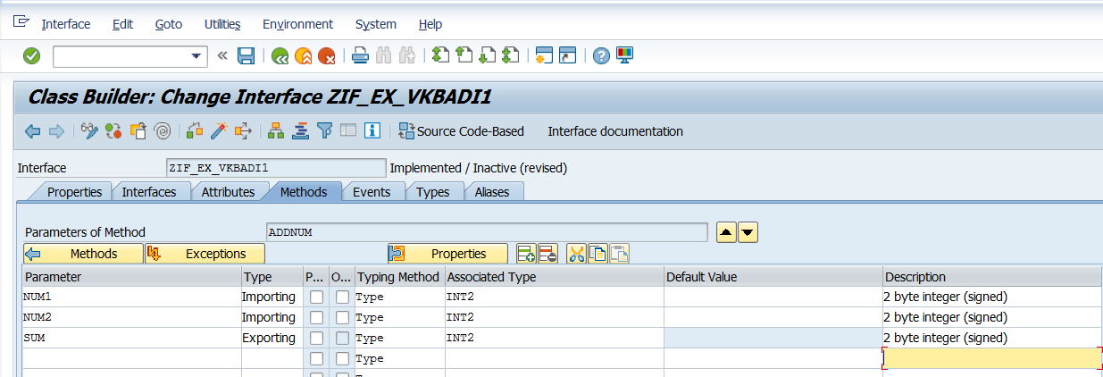

Save, Activate, Go Back.

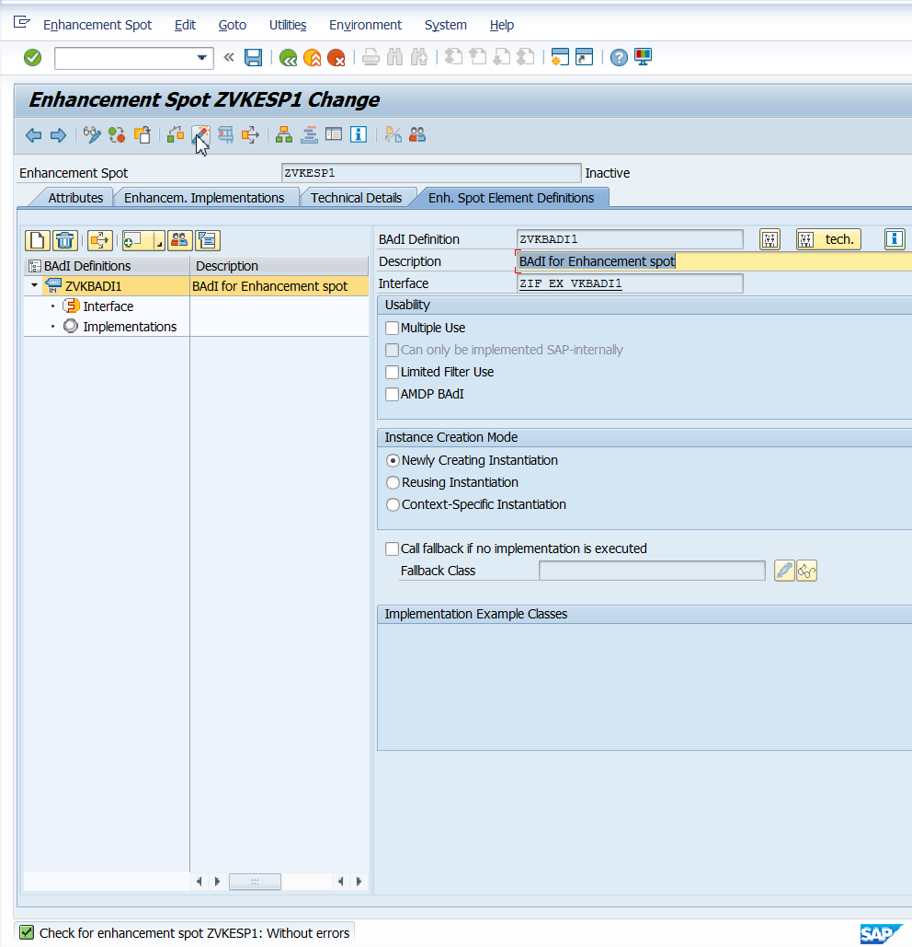

SE19

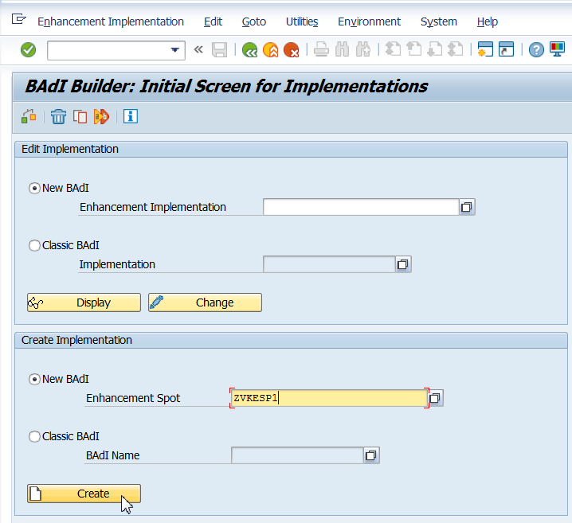

Give Enhancement Spot Implementation name, short text and continue 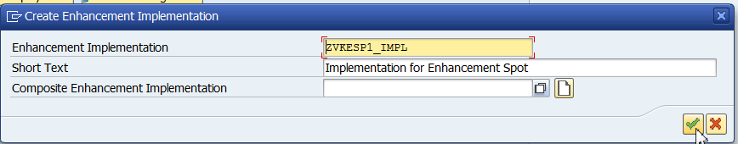

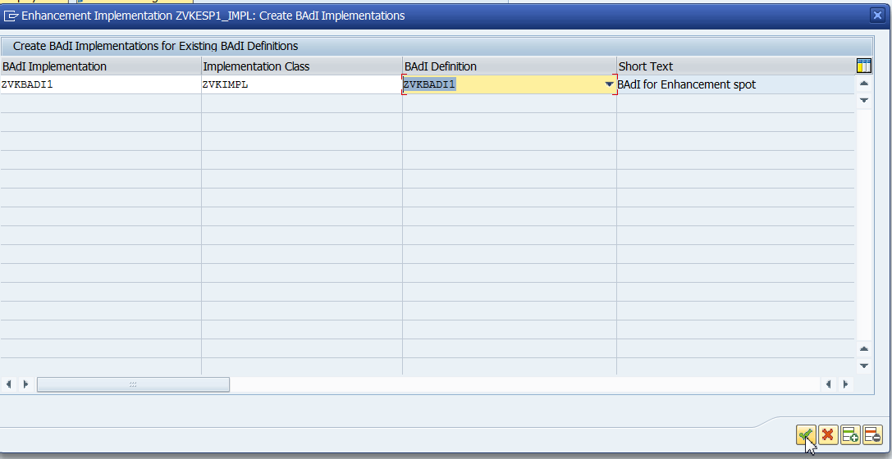

Give the BADI Implementation Name, Implementation Class, BAdI Definition and continue 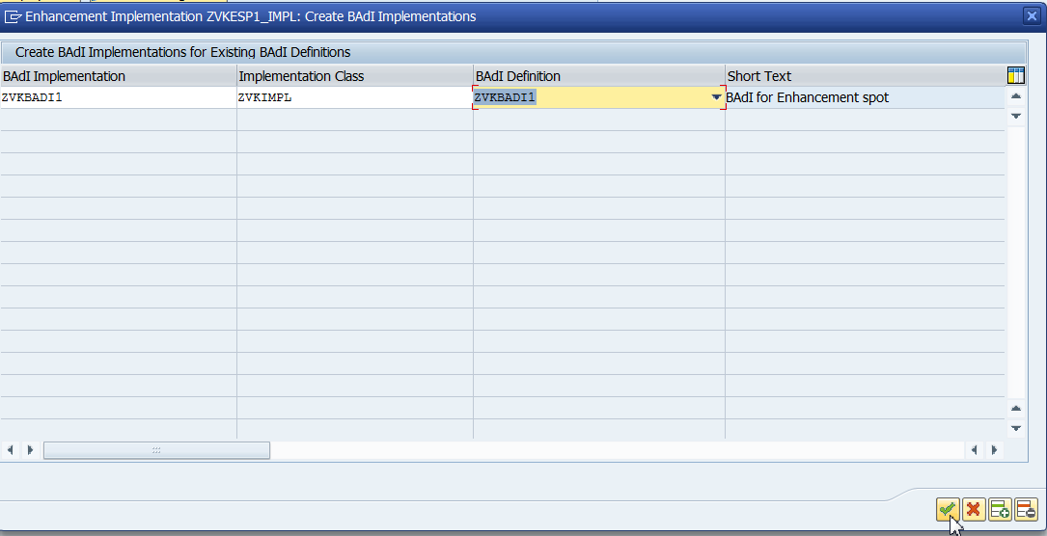Double Click on Implementing Class.

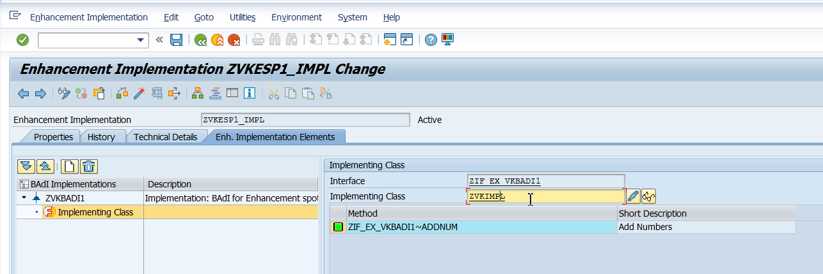Double click on the method to implement the method of the BAdI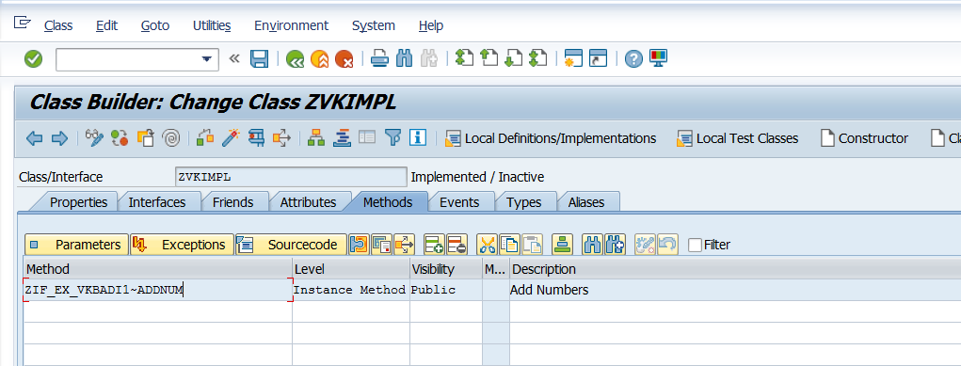Save and activate.

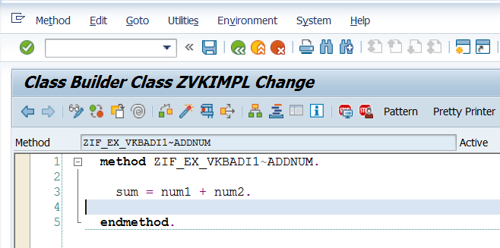

Call the above in SE38 program. See Text document (Create Enhancement Spot).

|  |  |  |  |
| --- | --- | --- | --- |
| Enhancement Spot |  |  | ZVKESP1 |
| BADI Definition |  |  | ZVKBADI1 |
| Interface |  |  | ZIF_EX_VKBADI1 |
|  |  |  |  |
| imp |  |  | ZVKESP1 |
| Enh impl |  |  | ZVKESP1_IMPL |
|  | BADI Impl | Imp Class | Badi Def |
|  | ZVKBADI1 | ZVKIMPL | ZVKBADI1 |